PUNKT / technical rider

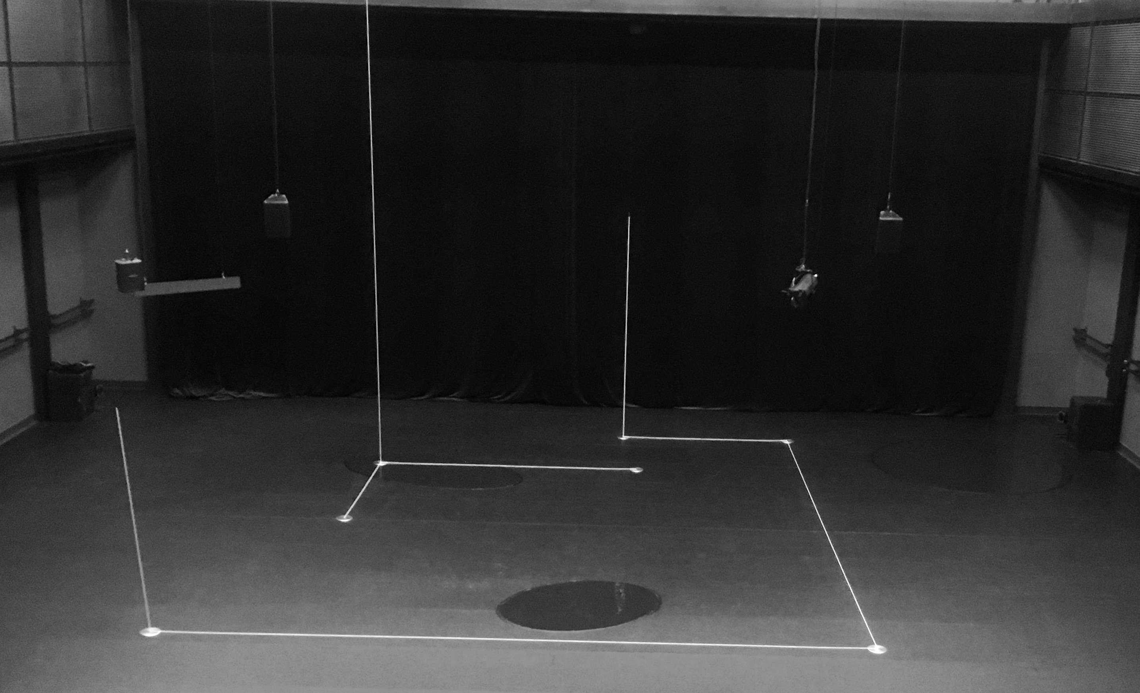

Show about 50 min / no break

Cast on stage : 3 dancers ( 2 female, 1 male )

Scene Open scene min 12m x 12m
Please contact us if necessary…

Fly bars Please contact us if you do not have fly bars
Also when hanging in the set / light / sound is, or becomes difficult.
- Please notice attached plans

Our set We bring :

A set / installation made met with white rope ( 5 mm ) en 7 metal discs.
- electromagnet in “grid” ( notice special EFX )
- shapes black hi-shine ballet floor that will be on your black floor.
A 1m 80 LED screen suspended on 2 cables
In our set : a wireless sound speaker turning around on cable and electric motor.
Some props ( e.g. black balloons .... )

The host venue / theater provides :

A flat floor location / venue with a grandstand ( is an ideal set up )

Black shatterproof theatre floor ( nude feet dancers ) min 12m X 12m
Using black dance floor ? It must be taped under ! (no lines on the floor )
A movable plain black fond ( backdrop or background )

Light The host venue / theater provides :

A general front open white

At least 36 dimmers 3 kW
PC 1kW 1 on a floor stand
PC 2 kW 9x
Zoomprofile 15-35° 1 kW 10 x ( 2 on a floor stand )
Zoomprofile 25-40° 2 kW 9x

See attached lighting plots for details

We bring :

1 PC 2 kW ( EFX rotating disc ) + rigging
1 pinspot/par36
1 profile 2kW ( Gobo )
Gobo rotator/gobo
Grand ma2 command wing
“Custom” LEE color filters

Sound The host venue / theater provides :

4x high quality full range (12”) speakers hanging upstage (ref plan)
2x SUB woofers ( + Delay in zaal )
Enough power en coverage adapted to the location
(ex. MEYER/D&B/NEXO).
Delay speakers if necessary
- high quality full range (12”) speaker behind the audience (ref plan)

All speakers are controlled separately, a total of 6 outputs !

We bring :

Midas M32r console
Laptop with Ableton showfile
Platform-M+ midi controller
Bose S1 pro system hanging on a mirror ball motor
In ear system connected to the Bose speaker
Our in ear system (Sennheiser ew300 G2) works within freq 830.000 - 866.000Mhz
--- Contact us if these frequencies are a problem !
1sennheiser mke600 mic on stage

Special EFX The upright rope falls during the performance ( e magnet )

Crew KVS company crew 1 stage manager✱ - 1 light - 1 sound

Set up start : contact the stage manager please

Your crew ( build up ) 1 stage / fly - bars - 1 light - 1 sound
During show standby light and sound

Build down max 1h.30 min

Surtitles No translation required

Costumes Is there a dresser provided at the host theatre ?
Short 30° programme : shorts and jumpsuits + underwear : Airdry ! Do not wash the harnesses. No ironing, a little steam if necessary.

Dressing rooms 3 dressing rooms

coffee – tea - water

Shower – towels – fresh fruit, nut mix and snacks

1 production room with WIFI

Car park A parking spot for 1 small truck
2 production cars

The host theatre / venue will keep us informed and will inform us in case of :
Any problems concerning loading, technical difficulties etc…

These are reported to :

Contact Lieven Symaeys ✱
( do use e-mail please )
0032 486 456 725
lieven.symaeys@kvs.be

Donald Berlanger
0032 2 210 11 61 @KVS
donald.berlanger@kvs.be

This technical rider is a part of the contract with the KVS

